**Name:Kundan Kabra  
Gr No: 21810729  
Roll No: 321023  
Div: A-1**

**3 B :-**

%{

/*

* Word recognizer with a symbol table.

*/

enum{

LOOKUP = 0, /* default-looking rather than defining. */

VERB,

ADJ,

ADV,

NOUN,

PREP,

PRON,

CONJ,

INT

};

int state;

int add_word(int type, char *word);

int lookup_word(char *word);

%}

%%

\n {state = LOOKUP; }

/* whenever a line starts with a reserved part of speech name */

/* start defining words of that type */

^verb { state = VERB; }

^adj { state = ADJ; }

^adv { state = ADV; }

^noun { state = NOUN; }

^prep { state = PREP; }

^pron { state = PRON; }

^conj { state = CONJ; }

^int { state = INT; }

/* a normal word, define it or look it up */

[a-zA-Z]+ {

if(state != LOOKUP) {

/* define the current word */

add_word(state, yytext);

} else {

switch(lookup_word(yytext)) {

case VERB: printf("%s: verb\n", yytext); break;

case ADJ: printf("%s: adjective\n", yytext); break;

case ADV: printf("%s: adverb\n", yytext); break;

case NOUN: printf("%s: noun\n", yytext); break;

case PREP: printf("%s: preposition\n", yytext); break;

case PRON: printf("%s: pronoun\n", yytext); break;

case CONJ: printf("%s: conjunction\n", yytext); break;

case INT: printf("%s: interjection\n", yytext); break;

default:

printf("%s: don't recognize\n", yytext) ;

break;

}

}

}

. /* ignore anything else */;

%%

int yywrap(void)

{

}

int main()

{

yylex();

}

/* define a linked list of words and types */

struct word{

char *word_name;

int word_type;

struct word *next;

};

struct word *word_list; /* first element in word list */

extern void *malloc();

int add_word(int type,char *word)

{

struct word *wp;

if(lookup_word(word) != LOOKUP) {

printf (" ! ! ! warning: word %s already defined \n",word);

return 0;

}

/* word not there, allocate a new entry and link it on the list */

wp = (struct word *) malloc(sizeof(struct word) );

wp->next = word_list;

/* have to copy the word itself as well */

wp->word_name = (char *) malloc(strlen(word)+1);

strcpy(wp->word_name,word);

wp->word_type = type;

word_list = wp;

return 1; /* it worked */

}

int lookup_word(char *word)

{

struct word *wp = word_list;

/* search down the list looking for the word */

for (; wp; wp = wp->next) {

if(strcmp(wp->word_name, word) == 0)

return wp->word_type;

}

return LOOKUP; /* not found */

}

**OUTPUT :-**

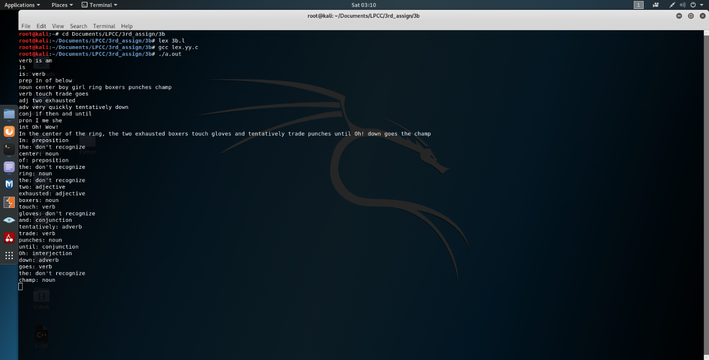

**3D :-**

%{

/*

* Word recognizer with a symbol table.

*/

enum {

LOOKUP =0, /* default - looking rather than defining. */

KEYWORD,

IDENTIFIER,

NUMBER,

LOGICAL,

ARITHMETIC,

RELATIONAL,

FORMAT,

PUNC,

ASSIGN

};

int state;

int add_word(int type, char *word);

int lookup_word(char *word);

%}

%%

\n { state = LOOKUP; } /* end of line, return to default state */

/* whenever a line starts with a reserved part of speech name */

/* start defining words of that type */

^keyword { state = KEYWORD; }

^identifier { state = IDENTIFIER; }

^number { state = NUMBER; }

^logical { state = LOGICAL; }

^arithmetic { state = ARITHMETIC; }

^relational { state = RELATIONAL; }

^format { state = FORMAT; }

^punc { state = PUNC; }

^assign { state = ASSIGN; }

[a-zA-Z0-9\.&&\|\|\+-\/%\*\<\>==\<=\>=%d%s%f%s\{\}\,\;\':\"\?\!()]+ {

/* a normal word, define it or look it up */

if(state != LOOKUP) {

/* define the current word */

add_word(state, yytext);

} else {

switch(lookup_word(yytext)) {

case KEYWORD: printf("%s: keyword\n", yytext); break;

case IDENTIFIER: printf("%s: identifier\n", yytext); break;

case NUMBER: printf("%s: number\n", yytext); break;

case LOGICAL: printf("%s: Logical operator\n", yytext); break;

case ARITHMETIC: printf("%s: Aritmetic operator\n", yytext); break;

case RELATIONAL: printf("%s: Relational operator\n", yytext); break;

case FORMAT: printf("%s: Format Specifier\n", yytext); break;

case PUNC: printf("%s: Punctuation Symbol\n", yytext); break;

case ASSIGN: printf("%s: Assignment Op\n", yytext); break;

default:

printf("%s: didn't recognize\n", yytext);

break;

}

}

}

. /* ignore anything else */ ;

%%

int yywrap(void)

{

}

int main()

{

yylex();

}

/* define a linked list of words and types */

struct word {

char *word_name;

int word_type;

struct word *next;

};

struct word *word_list; /* first element in word list */

extern void *malloc() ;

int

add_word(int type, char *word)

{

struct word *wp;

if(lookup_word(word) != LOOKUP) {

printf("!!! warning: word %s already defined \n", word);

return 0;

}

/* word not there, allocate a new entry and link it on the list */

wp = (struct word *) malloc(sizeof(struct word));

wp->next = word_list;

/* have to copy the word itself as well */

wp->word_name = (char *) malloc(strlen(word)+1);

strcpy(wp->word_name, word);

wp->word_type = type;

word_list = wp;

return 1; /* it worked */

}

int

lookup_word(char *word)

{

struct word *wp = word_list;

/* search down the list looking for the word */

for(; wp; wp = wp->next) {

if(strcmp(wp->word_name, word) == 0)

return wp->word_type;

}

return LOOKUP; /* not found */

}

**OUTPUT :-**

